1. Download the webdriver manager from :

<https://jar-download.com/artifact-search/webdrivermanager>

2. Click on the encircle link to start download.

3. After the creation of project Right click on the project

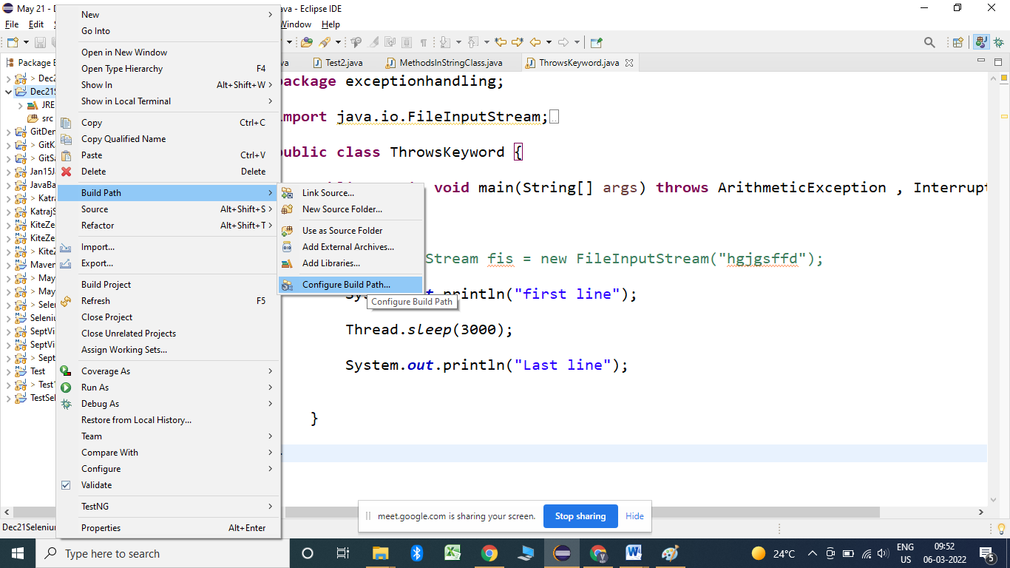

6. click on configure build path:

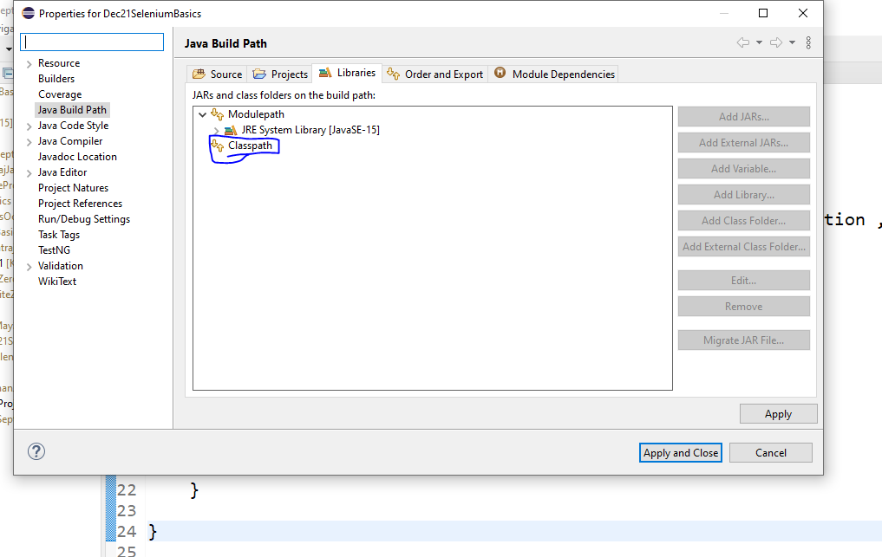

Click on the class path, then click on add external jars and select the folder where the jar files that got extracted files.

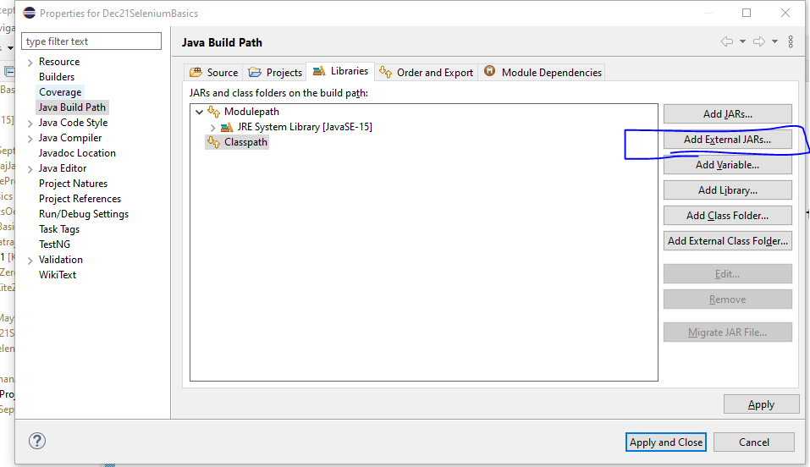

Select all the jar files and click on apply and close.

Then write the code:

**public** **static** **void** main(String[] args) {

WebDriverManager.*chromedriver*().setup();

WebDriver driver = **new** ChromeDriver();

}

Chrome browser will get launch.